UNIT 2 ENTITY-RELATIONSHIP MODEL

    - The term database application refers to a particular database and the associated programs that implement the database queries and updates.
    - For example, a BANK database application that keeps track of customer accounts would include programs that implement database updates corresponding to customer deposits and withdrawals. These programs provide user-friendly graphical user interfaces (GUIs) utilizing forms and menus for the end users of the application— the bank tellers, in this example. Hence, a major part of the database application will require the design, implementation, and testing of these application programs.
    - Traditionally, the design and testing of application programs has been considered to be part of software engineering rather than database design. In many software design tools, the database design methodologies and software engineering methodologies are intertwined since these activities are strongly related.
    - Entity-Relationship (ER) model is a popular high-level conceptual data model. This model and its variations are frequently used for the conceptual design of database applications, and many database design tools employ its concepts.
The diagrammatic notation associated with the ER model is known as ER diagrams.

A Sample Database Application

    - Consider a sample database application, called COMPANY, which serves to illustrate the basic ER model concepts and their use in schema design.
    - The company is organized into departments. Each department has a unique name, a unique number, and a particular employee who manages the department. We keep track of the start date when that employee began managing the department. A department may have several locations.
    - A department controls a number of projects, each of which has a unique name, a unique number, and a single location.
    - We store each employee’s name, Social Security number, address, salary, sex (gender), and birth date. An employee is assigned to one department, but may work on several projects, which are not necessarily controlled by the same department. We keep track of the current number of hours per week that an employee works on each project. We also keep track of the direct supervisor of each employee (who is another employee).
    - We want to keep track of the dependents of each employee for insurance purposes. We keep each dependent’s first name, sex, birth date, and relation-ship to the employee.
    - Figure shows how the schema for this database application can be displayed by means of the graphical notation known as ER diagrams. This figure will be explained gradually as the ER model concepts are presented. We describe the step-by-step process of deriving this schema from the stated requirements—and explain the ER diagrammatic notation—as we introduce the ER model concepts.

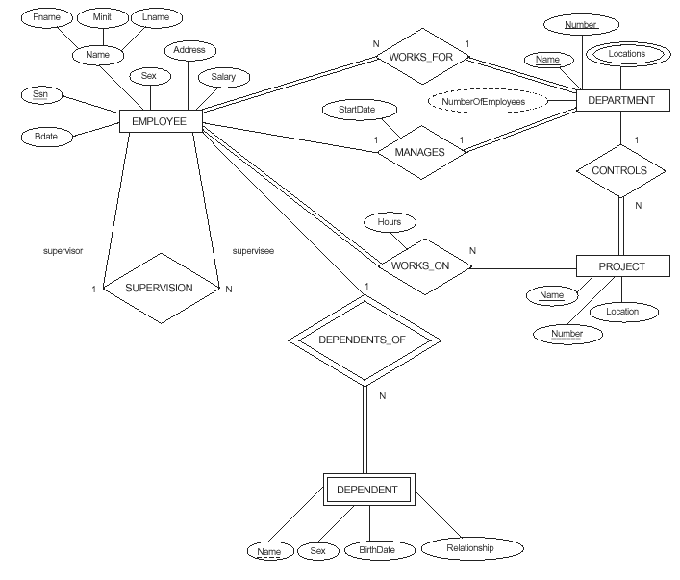

Components of ER diagram:
ER diagram basically having three components:
- Entities − It is a real-world thing which can be a person, place, or even a concept. For Example: Department, Admin, Courses, Teachers, Students, Building, etc are some of the entities of a School Management System.
- Attributes − An entity which contains a real-world property called an attribute. For Example: The entity employee has the property like employee id, salary, age, etc.
- Relationship − Relationship tells how two attributes are related. For Example: Employee works for a department.

Entity

An entity is an object or component of data. An entity is represented as rectangle in an ER diagram.
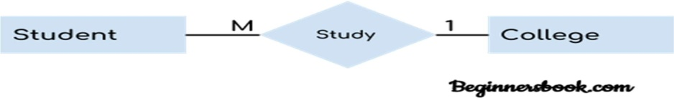
For example: In the following ER diagram we have two entities Student and College and these two entities have many to one relationship as many students study in a single college. We will read more about relationships later, for now focus on entities.

Weak Entity:

An entity that cannot be uniquely identified by its own attributes and relies on the relationship with other entity is called weak entity. The weak entity is represented by a double rectangle. For example – a bank account cannot be uniquely identified without knowing the bank to which the account belongs, so bank account is a weak entity.
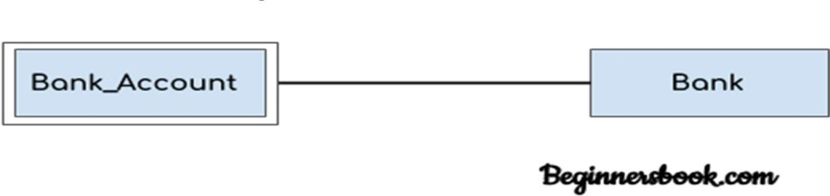

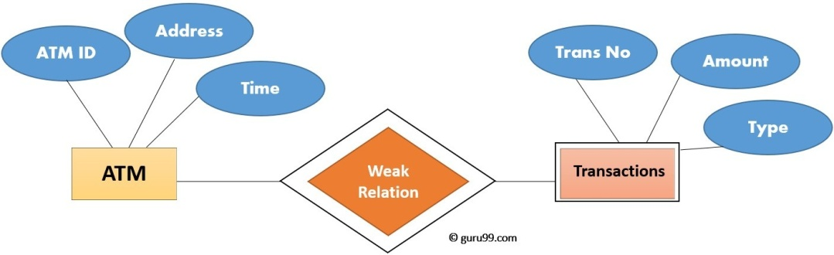

In above example, "Trans No" is a discriminator within a group of transactions in an ATM. Let's learn more about a weak entity by comparing it with a Strong Entity

Strong Entity Set | Weak Entity Set
Strong entity set always has a primary key. | It does not have enough attributes to build a primary key.
It is represented by a rectangle symbol. | It is represented by a double rectangle symbol.
It contains a Primary key represented by the underline symbol. | It contains a Partial Key which is represented by a dashed underline symbol.
The member of a strong entity set is called as dominant entity set. | The member of a weak entity set called as a subordinate entity set.
Primary Key is one of its attributes which helps to identify its member. | In a weak entity set, it is a combination of primary key and partial key of the strong entity set.
In the ER diagram the relationship between two strong entity set shown by using a diamond symbol. | The relationship between one strong and a weak entity set shown by using the double diamond symbol.
The connecting line of the strong entity set with the relationship is single. | The line connecting the weak entity set for identifying relationship is double.

Attribute
An attribute describes the property of an entity. An attribute is represented as Oval in an ER diagram. There are four types of attributes:
- Key attribute
- Composite attribute
- Multivalued attribute
- Derived attribute

Key attribute:

A key attribute can uniquely identify an entity from an entity set. For example, student roll number can uniquely identify a student from a set of students. Key attribute is represented by oval same as other attributes however the text of key attribute is underlined.
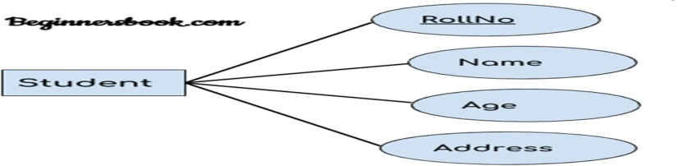

- Composite attribute: An attribute that is a combination of other attributes is known as composite attribute. For example, In student entity, the student address is a composite attribute as an address is composed of other attributes such as pin code, state, country.
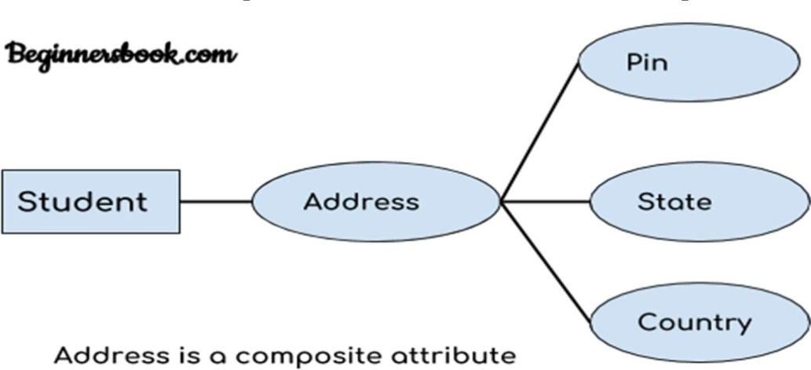

Multivalued attribute:

An attribute that can hold multiple values is known as multivalued attribute. It is represented with double ovals in an ER Diagram. For example – A person can have more than one phone numbers so the phone number attribute is multivalued.

Derived attribute:

A derived attribute is one whose value is dynamic and derived from another attribute. It is represented by dashed oval in an ER Diagram. For example – Person age is a derived attribute as it changes over time and can be derived from another attribute (Date of birth).

E-R diagram with multivalued and derived attributes:
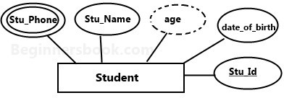

3. Relationship
The association among entities is called a relationship. For example, an employee works_at a department, a student enrolls in a course. Here, Works_at and Enrolls are called relationships.

Relationship Set
A set of relationships of similar type is called a relationship set. Like entities, a relationship too can have attributes. These attributes are called descriptive attributes.
Degree of a relationship set:
The number of different entity sets participating in a relationship set is called as degree of a relationship set.
1. Unary Relationship –
When there is only ONE entity set participating in a relation, the relationship is called as unary relationship. For example, one person is married to only one person.
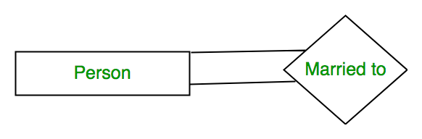
2. Binary Relationship –
When there are TWO entities set participating in a relation, the relationship is called as binary relationship.For example, Student is enrolled in Course.
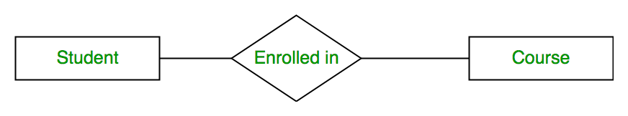
3. n-ary Relationship –
When there are n entities set participating in a relation, the relationship is called as n-ary relationship.

Cardinality: Defines the numerical attributes of the relationship between two entities or entity sets.

A relationship is represented by diamond shape in ER diagram, it shows the relationship among entities. There are four types of cardinal relationships:
- One to One
- One to Many
- Many to One
- Many to Many

One to One Relationship

When a single instance of an entity is associated with a single instance of another entity then it is called one to one relationship. For example, a person has only one passport and a passport is given to one person.

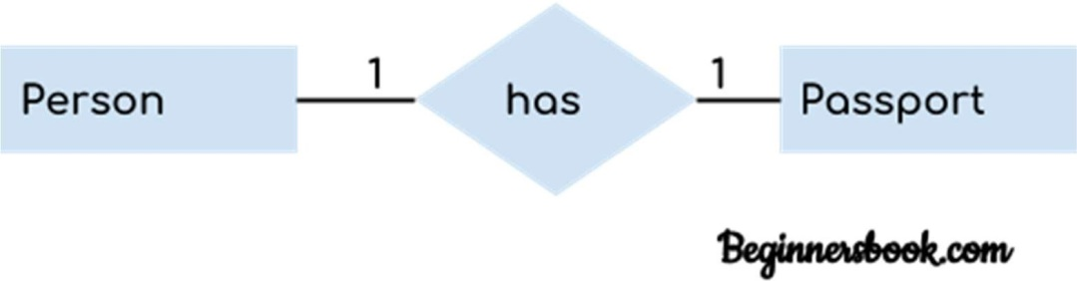

One to Many Relationship

When a single instance of an entity is associated with more than one instances of another entity then it is called one to many relationship. For example – a customer can place many orders but a order cannot be placed by many customers.

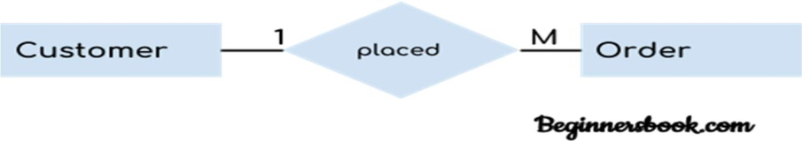

Many to One Relationship

When more than one instances of an entity is associated with a single instance of another entity then it is called many to one relationship. For example – many students can study in a single college but a student cannot study in many colleges at the same time.
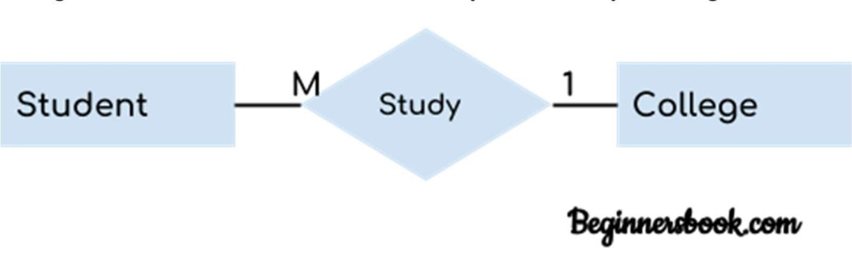

Best Practices for Developing Effective ER Diagrams
Here are some best practice or example for Developing Effective ER Diagrams.
- Eliminate any redundant entities or relationships
- You need to make sure that all your entities and relationships are properly labeled
- There may be various valid approaches to an ER diagram. You need to make sure that the ER diagram supports all the data you need to store
- You should assure that each entity only appears a single time in the ER diagram
- Name every relationship, entity, and attribute are represented on your diagram
- Never connect relationships to each other
- You should use colors to highlight important portions of the ER diagram

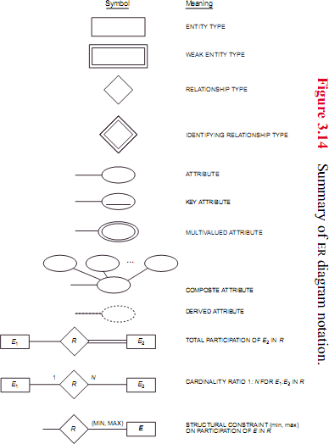

Enhanced ER Model

Today the complexity of the data is increasing so it becomes more and more difficult to use the traditional ER model for database modeling. To reduce this complexity of modeling we have to make improvements or enhancements to the existing ER model to make it able to handle the complex application in a better way.
Enhanced entity-relationship diagrams are advanced database diagrams very similar to regular ER diagrams which represent requirements and complexities of complex databases.
In addition to ER model concepts EE-R includes −
- Subclasses and Super classes.
- Specialization and Generalization.
- Category or union type.
- Aggregation.

Features of EER Model
- EER creates a design more accurate to database schemas.
- It reflects the data properties and constraints more precisely.
- It includes all modeling concepts of the ER model.
- Diagrammatic technique helps for displaying the EER schema.
- It includes the concept of specialization and generalization.
- It is used to represent a collection of objects that is union of objects of different of different entity types.

A. Sub Class and Super Class
Sub class and Super class relationship leads the concept of Inheritance.
The relationship between sub class and super class is denoted with  symbol.

1. Super Class
Super class is an entity type that has a relationship with one or more subtypes.
An entity cannot exist in database merely by being member of any super class.
For example: Shape super class is having sub groups as Square, Circle, Triangle.

2. Sub Class
Sub class is a group of entities with unique attributes.
Sub class inherits properties and attributes from its super class.
For example: Square, Circle, Triangle are the sub class of Shape super class.
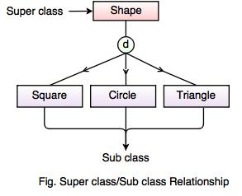
B. Specialization and Generalization
1. Generalization
Generalization is the process of generalizing the entities which contain the properties of all the generalized entities.
It is a bottom approach, in which two lower level entities combine to form a higher level entity.
Generalization is the reverse process of Specialization.
It defines a general entity type from a set of specialized entity type.
It minimizes the difference between the entities by identifying the common features.
For example:
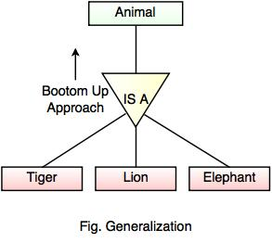
In the above example, Tiger, Lion, Elephant can all be generalized as Animals.
2. Specialization
Specialization is a process that defines a group entities which is divided into sub groups based on their characteristic.
It is a top down approach, in which one higher entity can be broken down into two lower level entity.
It maximizes the difference between the members of an entity by identifying the unique characteristic or attributes of each member.
It defines one or more sub class for the super class and also forms the superclass/subclass relationship.
For example
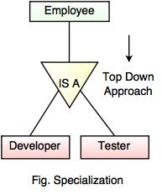
In the above example, Employee can be specialized as Developer or Tester, based on what role they play in an Organization.
C. Category or Union
Category represents a single super class or sub class relationship with more than one super class.
It can be a total or partial participation.
For example Car booking, Car owner can be a person, a bank (holds a possession on a Car) or a company. Category (sub class) → Owner is a subset of the union of the three super classes → Company, Bank, and Person. A Category member must exist in at least one of its super classes.

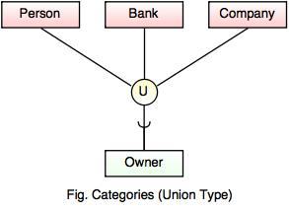
D. Aggregation
Aggregation is a process that represent a relationship between a whole object and its component parts.
It abstracts a relationship between objects and viewing the relationship as an object.
It is a process when two entity is treated as a single entity.
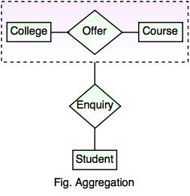
In the above example, the relation between College and Course is acting as an Entity in Rela

ER-to-Relational Mapping
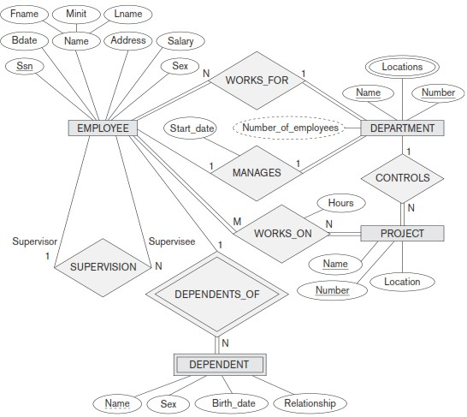

Step 1: Mapping of Regular Entity Types:
- Figure out all the regular/strong entity from the diagram and then create a corresponding relation(table) that includes all the simple attributes.
- Choose one of the attributes as a primary key. If composite, the simple attributes together form the primary key.
- For the given ER-Diagram we have Employee, Department and Project as strong/regular entity, as they are enclosed in single rectangle.
- So, we create respective relations that is depicted in the figure below.
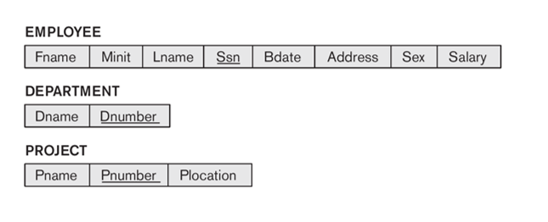

Step 2: Mapping of Weak Entity Types:
- Figure out the weak entity types from the diagram and create a corresponding relation(table) that includes all its simple attributes.
- Add as foreign key all of the primary key attributes in the entity corresponding to the owner entity.
- The primary key is a combination of all the primary key attributes from the owner and the primary key of the weak entity.
- For the given ER-Diagram we have Dependent as a weak entity, as it is enclosed in a double rectangle that is indicative of an entity being weak.
- The Dependent relation(table) is created that is shown in the figure below.
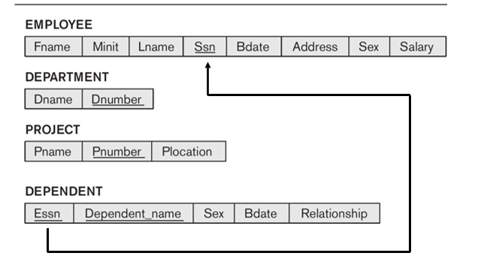

Step 3: Mapping of Binary 1:1 Relationship Types
- Now we need to figure out the entities from ER diagram for which there exists a 1-to-1 relationship.
- The entities for which there exists a 1-to-1 relationship, choose one relation(table) as S, the other as T.
Better if S has total participation (reduces the number of NULL values).
- Then we need to add to S all the simple attributes of the relationship if there exists any.
- After that, we add as a foreign key in S the primary key attributes of T.
- For the given ER-Diagram there exists a 1-to-1 relationship between Employee and Department entity.
- Here Department has total participation therefore consider it as relation S and Employee as relation T.
- The 1-to-1 mapping between Employee and Department is depicted in the figure below.
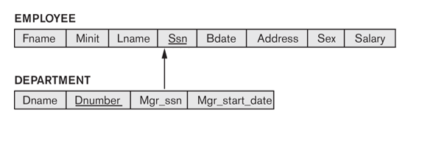
Step 4: Mapping of Binary 1:N Relationship Types
- Now we need to figure out the entities from ER diagram for which there exists a 1-to-N relationship.
- The entities for which there exists a 1-to-N relationship, choose a relation as S as the type at N-side of relationship and other as T.
- Then we add as a foreign key to S all of the primary key attributes of T.
- In the given ER diagram there are two 1-to-N relationships that exists between Employee-Department and Employee-Dependent entity.
- The 1-to-N mapping between Employee-Department and Employee-Dependent is depicted in the figure below.
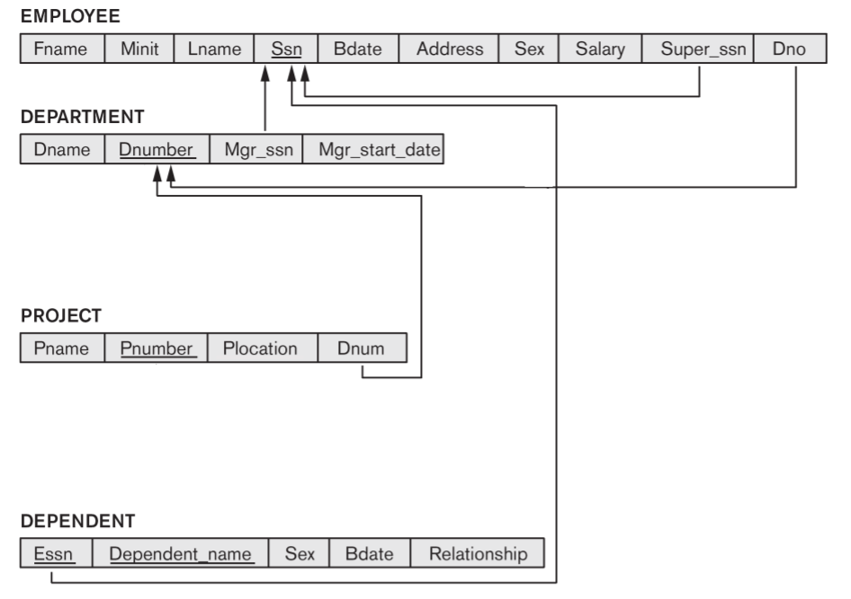

Step 5: Mapping of Binary M:N Relationship Types
- Now we need to figure out the entities from ER diagram for which there exists an M-to-N relationship.
- Create a new relation(table) S.
- The primary keys of relations(tables) between which M-to-N relationship exists, are added to the new relation S created, that acts as a foreign key.
- Then we,add any simple attributes of the M-to-N relationship to S.
- For the given ER-Diagram there exists M-to-N relationship between Employee and Project entity.
- The new table Works_On is created for mapping the relationship between Employee and Project relation(table).
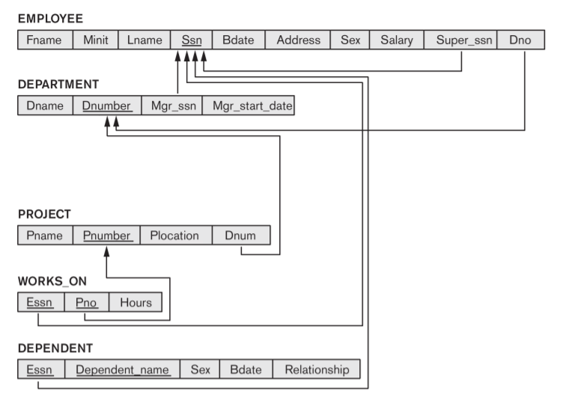

Step 6: Mapping of Multivalued Attributes
- Now identify the relations(tables) that contain multi-valued attributes.
- Then we need to create a new relation S
- In the new relation S we add as foreign keys the primary keys of the corresponding relation.
- Then we add the multi-valued attribute to S; the combination of all attributes in S forms the primary key.
- For the given ER-Diagram there exists a multi-valued attribute (Locations) in Department relation(table).
- So, we create a new relation called Dept_Locations. To this new relation we add the primary key of Department Table that is D_Number and the multi-valued attribute Locations.
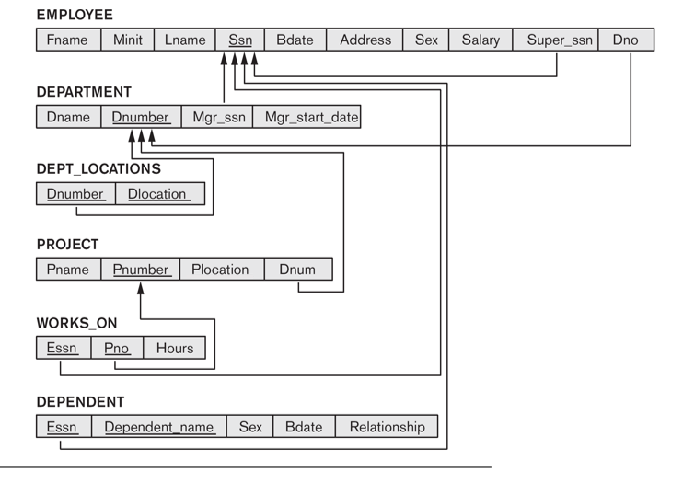
Step 7: Mapping of N-ary Relationship Types

Functional dependencies

A functional dependency is a constraint that specifies the relationship between two sets of attributes where one set can accurately determine the value of other sets. It is denoted as X → Y, where X is a set of attributes that is capable of determining the value of Y. The attribute set on the left side of the arrow, X is called Determinant, while on the right side, Y is called the Dependent.

Example:
roll_no | name | dept_name | dept_building
42 | abc | CO | A4
43 | pqr | IT | A3
44 | xyz | CO | A4
45 | xyz | IT | A3
46 | mno | EC | B2
47 | jkl | ME | B2

From the above table we can conclude some valid functional dependencies:

- roll_no → { name, dept_name, dept_building },→ Here, roll_no can determine values of fields name, dept_name and dept_building, hence a valid Functional dependency
- roll_no → dept_name , Since, roll_no can determine whole set of {name, dept_name, dept_building}, it can determine its subset dept_name also.
- dept_name → dept_building , Dept_name can identify the dept_building accurately, since departments with different dept_name will also have a different dept_building
- More valid functional dependencies: roll_no → name, {roll_no, name} ⇢ {dept_name, dept_building}, etc.

Here are some invalid functional dependencies:

- name → dept_name Students with the same name can have different dept_name, hence this is not a valid functional dependency.
- dept_building → dept_name There can be multiple departments in the same building, For example, in the above table departments ME and EC are in the same building B2, hence dept_building → dept_name is an invalid functional dependency.
- More invalid functional dependencies: name → roll_no, {name, dept_name} → roll_no, dept_building → roll_no, etc

.
Armstrong’s axioms/properties of functional dependencies:

- Reflexivity: If Y is a subset of X, then X→Y holds by reflexivity rule
For example, {roll_no, name} → name is valid.
- Augmentation: If X → Y is a valid dependency, then XZ → YZ is also valid by the augmentation rule.
For example, If {roll_no, name} → dept_building is valid, hence {roll_no, name, dept_name} → {dept_building, dept_name} is also valid.→
- Transitivity: If X → Y and Y → Z are both valid dependencies, then X→Z is also valid by the Transitivity rule.
For example, roll_no → dept_name & dept_name → dept_building, then roll_no → dept_building is also valid.

Types of Functional dependencies in DBMS:
- Trivial functional dependency
- Non-Trivial functional dependency
- Multivalued functional dependency
- Transitive functional dependency

1. Trivial Functional Dependency
In Trivial Functional Dependency, a dependent is always a subset of the determinant.
i.e. If X → Y and Y is the subset of X, then it is called trivial functional dependency
For example,
roll_no | name | age
42 | abc | 17
43 | pqr | 18
44 | xyz | 18
Here, {roll_no, name} → name is a trivial functional dependency, since the dependent name is a subset of determinant set {roll_no, name}
Similarly, roll_no → roll_no is also an example of trivial functional dependency.

2. Non-trivial Functional Dependency
In Non-trivial functional dependency, the dependent is strictly not a subset of the determinant.
i.e. If X → Y and Y is not a subset of X, then it is called Non-trivial functional dependency.
For example,
roll_no | name | age
42 | abc | 17
43 | pqr | 18
44 | xyz | 18
Here, roll_no → name is a non-trivial functional dependency, since the dependent name is not a subset of determinant roll_no
Similarly, {roll_no, name} → age is also a non-trivial functional dependency, since age is not a subset of {roll_no, name}

3. Multivalued Functional Dependency
In Multivalued functional dependency, entities of the dependent set are not dependent on each other.
i.e. If a → {b, c} and there exists no functional dependency between b and c, then it is called a multivalued functional dependency.
For example,
roll_no | name | age
42 | abc | 17
43 | pqr | 18
44 | xyz | 18
45 | abc | 19
Here, roll_no → {name, age} is a multivalued functional dependency, since the dependents name & age are not dependent on each other(i.e. name → age or age → name doesn’t exist !)

4. Transitive Functional Dependency
In transitive functional dependency, dependent is indirectly dependent on determinant.
i.e. If a → b & b → c, then according to axiom of transitivity, a → c. This is a transitive functional dependency
For example,
enrol_no | name | dept | building_no
42 | abc | CO | 4
43 | pqr | EC | 2
44 | xyz | IT | 1
45 | abc | EC | 2
Here, enrol_no → dept and dept → building_no,
Hence, according to the axiom of transitivity, enrol_no → building_no is a valid functional dependency. This is an indirect functional dependency, hence called Transitive functional dependency.

NON LOSS DECOMPOSITION (OR) LOSSLESS DECOMPOSITION :

Lossless-join decomposition is a process in which a relation is decomposed into two or more relations. This property guarantees that the extra or less tuple generation problem does not occur and no information is lost from the original relation during the decomposition. It is also known as non-additive join decomposition.
When the sub relations combine again then the new relation must be the same as the original relation was before decomposition.
Consider a relation R if we decomposed it into sub-parts relation R1 and relation R2.
The decomposition is lossless when it satisfies the following statement −
- If we union the sub Relation R1 and R2 then it must contain all the attributes that are available in the original relation R before decomposition.
- Intersections of R1 and R2 cannot be Null. The sub relation must contain a common attribute. The common attribute must contain unique data.
The common attribute must be a super key of sub relations either R1 or R2.
Here,
R = (A, B, C)
R1 = (A, B)
R2 = (B, C)
The relation R has three attributes A, B, and C. The relation R is decomposed into two relation R1 and R2. . R1 and R2 both have 2-2 attributes.The common attributes are B.
The Value in Column B must be unique. if it contains a duplicate value then the Lossless-join decomposition is not possible.
Draw a table of Relation R with Raw Data −
R (A, B, C)
A | B | C
12 | 25 | 34
10 | 36 | 09
12 | 42 | 30
It decomposes into the two sub relations −
R1 (A, B)
A | B
12 | 25
10 | 36
12 | 42
R2 (B, C)
B | C
25 | 34
36 | 09
42 | 30
Now, we can check the first condition for Lossless-join decomposition.
The union of sub relation R1 and R2 is the same as relation R.
R₁U R₂ = R
We get the following result −
A | B | C
12 | 25 | 34
10 | 36 | 09
12 | 42 | 30
The relation is the same as the original relation R. Hence, the above decomposition is Lossless-join decomposition.

Normalization:
    - The normalization process is first proposed by Codd (1972)
    - The normalization process takes a relation schema through a series of tests to certify whether it satisfies a certain normal form. The process, which proceeds in a top-down fashion by evaluating each relation against the criteria for normal forms and decomposing relations as necessary, can thus be considered as relational design by analysis.
    - Initially, Codd proposed three normal forms, which he called first, second, and third normal form. A stronger definition of 3NF—called Boyce-Codd normal form (BCNF)—was proposed later by Boyce and Codd. All these normal forms are based on a single analytical tool: the functional dependencies among the attributes of a relation. Later, a fourth normal form (4NF) and a fifth normal form (5NF) were proposed, based on the concepts of multivalued dependencies and join dependencies, respectively.

    - Normalization of data can be considered a process of analyzing the given relation schemas based on their FDs and primary keys to achieve the desirable properties of
- minimizing redundancy
- minimizing the insertion, deletion, and update anomalies

Example: Suppose a manufacturing company stores the employee details in a table named employee that has four attributes: emp_id for storing employee’s id, emp_name for storing employee’s name, emp_address for storing employee’s address and emp_dept for storing the department details in which the employee works. At some point of time the table looks like this:

emp_id | emp_name | emp_address | emp_dept
101 | Rick | Delhi | D001
101 | Rick | Delhi | D002
123 | Maggie | Agra | D890
166 | Glenn | Chennai | D900
166 | Glenn | Chennai | D004

The above table is not normalized. We will see the problems that we face when a table is not normalized.

Update anomaly: In the above table we have two rows for employee Rick as he belongs to two departments of the company. If we want to update the address of Rick then we have to update the same in two rows or the data will become inconsistent. If somehow, the correct address gets updated in one department but not in other then as per the database, Rick would be having two different addresses, which is not correct and would lead to inconsistent data.

Insert anomaly: Suppose a new employee joins the company, who is under training and currently not assigned to any department then we would not be able to insert the data into the table if emp_dept field doesn’t allow nulls.

Delete anomaly: Suppose, if at a point of time the company closes the department D890 then deleting the rows that are having emp_dept as D890 would also delete the information of employee Maggie since she is assigned only to this department.

To overcome these anomalies we need to normalize the data.

First Normal Form:
For a table to be in the First Normal Form, it should follow the following 4 rules:
- It should only have single(atomic) valued attributes/columns.
- Values stored in a column should be of the same domain
- All the columns in a table should have unique names.
- And the order in which data is stored, does not matter.

Rules for First Normal Form
The first normal form expects you to follow a few simple rules while designing your database, and they are:

Rule 1: Single Valued Attributes
Each column of your table should be single valued which means they should not contain multiple values. We will explain this with help of an example later, let's see the other rules for now.

Rule 2: Attribute Domain should not change
This is more of a "Common Sense" rule. In each column the values stored must be of the same kind or type.

Rule 3: Unique name for Attributes/Columns
This rule expects that each column in a table should have a unique name. This is to avoid confusion at the time of retrieving data or performing any other operation on the stored data.
If one or more columns have same name, then the DBMS system will be left confused.

Rule 4: Order doesn't matters
This rule says that the order in which you store the data in your table doesn't matter.

Example 1 – Relation STUDENT in table 1 is not in 1NF because of multi-valued attribute STUD_PHONE. Its decomposition into 1NF has been shown in table 2.
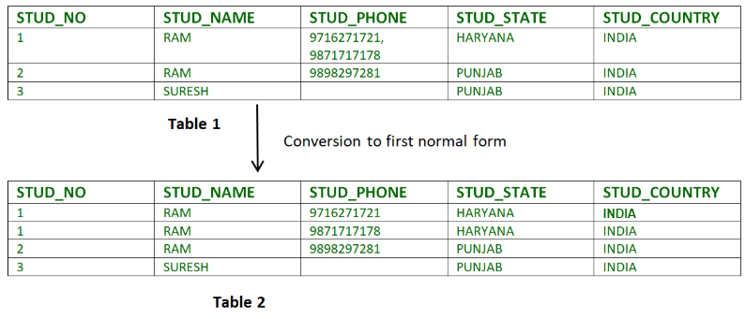
Example 2 –

ID Name Courses
------------------
1 A c1, c2
2 E c3
3 M C2, c3
In the above table Course is a multi-valued attribute so it is not in 1NF.
Below Table is in 1NF as there is no multi-valued attribute
ID Name Course
------------------
1 A c1
1 A c2
2 E c3
3 M c2
3 M c3

Second Normal Form (2NF)
For a table to be in the Second Normal Form,
- It should be in the First Normal form.
- And, it should not have Partial Dependency.
What is Partial Dependency? First let's understand what is Dependency in a table?

What is Dependency?
Let's take an example of a Student table with columns student_id, name, reg_no(registration number), branch and address(student's home address).
student_id | name | reg_no | branch | address
In this table, student_id is the primary key and will be unique for every row, hence we can use student_id to fetch any row of data from this table
Even for a case, where student names are same, if we know the student_id we can easily fetch the correct record.
student_id | name | reg_no | branch | address
10 | Akon | 07-WY | CSE | Kerala
11 | Akon | 08-WY | IT | Gujarat
Hence we can say a Primary Key for a table is the column or a group of columns(composite key) which can uniquely identify each record in the table.
I can ask from branch name of student with student_id 10, and I can get it. Similarly, if I ask for name of student with student_id 10 or 11, I will get it. So all I need is student_id and every other column depends on it, or can be fetched using it.
This is Dependency and we also call it Functional Dependency.

What is Partial Dependency?
Now that we know what dependency is, we are in a better state to understand what partial dependency is.
For a simple table like Student, a single column like student_id can uniquely identfy all the records in a table.
But this is not true all the time. So now let's extend our example to see if more than 1 column together can act as a primary key.
Let's create another table for Subject, which will have subject_id and subject_name fields and subject_id will be the primary key.
subject_id | subject_name
1 | Java
2 | C++
3 | Php
Now we have a Student table with student information and another table Subject for storing subject information.
Let's create another table Score, to store the marks obtained by students in the respective subjects. We will also be saving name of the teacher who teaches that subject along with marks.
score_id | student_id | subject_id | marks | teacher
1 | 10 | 1 | 70 | Java Teacher
2 | 10 | 2 | 75 | C++ Teacher
3 | 11 | 1 | 80 | Java Teacher
In the score table we are saving the student_id to know which student's marks are these and subject_id to know for which subject the marks are for.
Together, student_id + subject_id forms a Candidate Key(learn about Database Keys) for this table, which can be the Primary key.
Confused, How this combination can be a primary key?
See, if I ask you to get me marks of student with student_id 10, can you get it from this table? No, because you don't know for which subject. And if I give you subject_id, you would not know for which student. Hence we need student_id + subject_id to uniquely identify any row.

But where is Partial Dependency?
Now if you look at the Score table, we have a column names teacher which is only dependent on the subject, for Java it's Java Teacher and for C++ it's C++ Teacher & so on.
Now as we just discussed that the primary key for this table is a composition of two columns which is student_id & subject_id but the teacher's name only depends on subject, hence the subject_id, and has nothing to do with student_id.
This is Partial Dependency, where an attribute in a table depends on only a part of the primary key and not on the whole key.

How to remove Partial Dependency?
There can be many different solutions for this, but out objective is to remove teacher's name from Score table.
The simplest solution is to remove columns teacher from Score table and add it to the Subject table. Hence, the Subject table will become:
subject_id | subject_name | teacher
1 | Java | Java Teacher
2 | C++ | C++ Teacher
3 | Php | Php Teacher
And our Score table is now in the second normal form, with no partial dependency.
score_id | student_id | subject_id | marks
1 | 10 | 1 | 70
2 | 10 | 2 | 75
3 | 11 | 1 | 80

Third Normal Form (3NF)
A table is said to be in the Third Normal Form when,
- It is in the Second Normal form.
- And, it doesn't have Transitive Dependency.

Requirements for Third Normal Form
For a table to be in the third normal form,
- It should be in the Second Normal form.
- And it should not have Transitive Dependency.

What is Transitive Dependency?
With exam_name and total_marks added to our Score table, it saves more data now. Primary key for our Score table is a composite key, which means it's made up of two attributes or columns → student_id + subject_id.
Our new column exam_name depends on both student and subject. For example, a mechanical engineering student will have Workshop exam but a computer science student won't. And for some subjects you have Prctical exams and for some you don't. So we can say that exam_name is dependent on both student_id and subject_id.
And what about our second new column total_marks? Does it depend on our Score table's primary key?
Well, the column total_marks depends on exam_name as with exam type the total score changes. For example, practicals are of less marks while theory exams are of more marks.
But, exam_name is just another column in the score table. It is not a primary key or even a part of the primary key, and total_marks depends on it.
This is Transitive Dependency. When a non-prime attribute depends on other non-prime attributes rather than depending upon the prime attributes or primary key.

How to remove Transitive Dependency?
Again the solution is very simple. Take out the columns exam_name and total_marks from Score table and put them in an Exam table and use the exam_id wherever required.

Score Table: In 3rd Normal Form
score_id | student_id | subject_id | marks | exam_id

The new Exam table
exam_id | exam_name | total_marks
1 | Workshop | 200
2 | Mains | 70
3 | Practicals | 30

Advantage of removing Transitive Dependency
The advantage of removing transitive dependency is,
- Amount of data duplication is reduced.
- Data integrity achieved.

Boyce and Codd Normal Form (BCNF)
Boyce and Codd Normal Form is a higher version of the Third Normal form. This form deals with certain type of anomaly that is not handled by 3NF. A 3NF table which does not have multiple overlapping candidate keys is said to be in BCNF. For a table to be in BCNF, following conditions must be satisfied:
- R must be in 3rd Normal Form
- and, for each functional dependency ( X → Y ), X should be a super Key.

Rules for BCNF
For a table to satisfy the Boyce-Codd Normal Form, it should satisfy the following two conditions:
- It should be in the Third Normal Form.
- And, for any dependency A → B, A should be a super key.
The second point sounds a bit tricky, right? In simple words, it means, that for a dependency A → B, A cannot be a non-prime attribute, if B is a prime attribute.

Example
Below we have a college enrolment table with columns student_id, subject and professor.
student_id | subject | professor
101 | Java | P.Java
101 | C++ | P.Cpp
102 | Java | P.Java2
103 | C# | P.Chash
104 | Java | P.Java
As you can see, we have also added some sample data to the table.
In the table above:
- One student can enrol for multiple subjects. For example, student with student_id 101, has opted for subjects - Java & C++
- For each subject, a professor is assigned to the student.
- And, there can be multiple professors teaching one subject like we have for Java.
What do you think should be the Primary Key?
Well, in the table above student_id, subject together form the primary key, because using student_id and subject, we can find all the columns of the table.
One more important point to note here is, one professor teaches only one subject, but one subject may have two different professors.
Hence, there is a dependency between subject and professor here, where subject depends on the professor name.
This table satisfies the 1st Normal form because all the values are atomic, column names are unique and all the values stored in a particular column are of same domain.
This table also satisfies the 2nd Normal Form as their is no Partial Dependency.
And, there is no Transitive Dependency, hence the table also satisfies the 3rd Normal Form.
But this table is not in Boyce-Codd Normal Form.

Why this table is not in BCNF?
In the table above, student_id, subject form primary key, which means subject column is a prime attribute.
But, there is one more dependency, professor → subject.
And while subject is a prime attribute, professor is a non-prime attribute, which is not allowed by BCNF.

How to satisfy BCNF?
To make this relation(table) satisfy BCNF, we will decompose this table into two tables, student table and professor table.
Below we have the structure for both the tables.
Student Table
student_id | p_id
101 | 1
101 | 2
and so on...
And, Professor Table
p_id | professor | subject
1 | P.Java | Java
2 | P.Cpp | C++
and so on...
And now, this relation satisfy Boyce-Codd Normal Form.

Fourth Normal Form (4NF)
A table is said to be in the Fourth Normal Form when,
- It is in the Boyce-Codd Normal Form.
- And, it doesn't have Multi-Valued Dependency.

Rules for 4th Normal Form
For a table to satisfy the Fourth Normal Form, it should satisfy the following two conditions:
- It should be in the Boyce-Codd Normal Form.
- And, the table should not have any Multi-valued Dependency.
Let's try to understand what multi-valued dependency

What is Multi-valued Dependency?
A table is said to have multi-valued dependency, if the following conditions are true,
- For a dependency A → B, if for a single value of A, multiple value of B exists, then the table may have multi-valued dependency.
- Also, a table should have at-least 3 columns for it to have a multi-valued dependency.
- And, for a relation R(A,B,C), if there is a multi-valued dependency between, A and B, then B and C should be independent of each other.
If all these conditions are true for any relation(table), it is said to have multi-valued dependency.

Example
Below we have a college enrolment table with columns s_id, course and hobby.
s_id | course | hobby
1 | Science | Cricket
1 | Maths | Hockey
2 | C# | Cricket
2 | Php | Hockey
As you can see in the table above, student with s_id 1 has opted for two courses, Science and Maths, and has two hobbies, Cricket and Hockey.
You must be thinking what problem this can lead to, right?
Well the two records for student with s_id 1, will give rise to two more records, as shown below, because for one student, two hobbies exists, hence along with both the courses, these hobbies should be specified.
s_id | course | hobby
1 | Science | Cricket
1 | Maths | Hockey
1 | Science | Hockey
1 | Maths | Cricket
And, in the table above, there is no relationship between the columns course and hobby. They are independent of each other.
So there is multi-value dependency, which leads to un-necessary repetition of data and other anomalies as well.

How to satisfy 4th Normal Form?
To make the above relation satify the 4th normal form, we can decompose the table into 2 tables.
CourseOpted Table
s_id | course
1 | Science
1 | Maths
2 | C#
2 | Php
And, Hobbies Table,
s_id | hobby
1 | Cricket
1 | Hockey
2 | Cricket
2 | Hockey
Now this relation satisfies the fourth normal form.
A table can also have functional dependency along with multi-valued dependency. In that case, the functionally dependent columns are moved in a separate table and the multi-valued dependent columns are moved to separate tables.
If you design your database carefully, you can easily avoid these issues.

FIFTH NORML FORM
A database is said to be in 5NF, if and only if,
- It's in 4NF
- If we can decompose table further to eliminate redundancy and anomaly, and when we re-join the decomposed tables by means of candidate keys, we should not be losing the original data or any new record set should not arise. In simple words, joining two or more decomposed table should not lose records nor create new records.
What is Join Dependency
If a table can be recreated by joining multiple tables and each of this table have a subset of the attributes of the table, then the table is in Join Dependency. It is a generalization of Multivalued Dependency Join Dependency can be related to 5NF, wherein a relation is in 5NF, only if it is already in 4NF and it cannot be decomposed further.
Example
<Employee>
 |  | EmpName |  | EmpSkills |  | EmpJob (Assigned Work)
 |  | Tom |  | Networking |  | EJ001
 |  | Harry |  | Web Development |  | EJ002
 |  | Katie |  | Programming |  | EJ002
The abo  <Emp |  | ve table can be decomposed into the following three tables; therefore it is not in 5NF:  loyeeSkills>
 |  |  | EmpName |  | EmpSkills
 |  |  | Tom |  | Networking
 |  |  | Harry |  | Web Development
 |  |  | Katie |  | Programming
<EmployeeJob>
 |  |  | EmpName |  | EmpJob
 |  |  | Tom |  | EJ001
 |  |  | Harry |  | EJ002
 |  |  | Katie |  | EJ002
<JobSkills>
 |  |  | EmpSkills |  | EmpJob
 |  |  | Networking |  | EJ001
 |  |  | Web Development |  | EJ002
 |  |  | Programming |  | EJ002
Our Join Dependency:
 | {(EmpName, EmpSkills ), ( EmpName, EmpJob), (EmpSkills, EmpJob)}

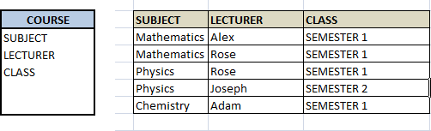
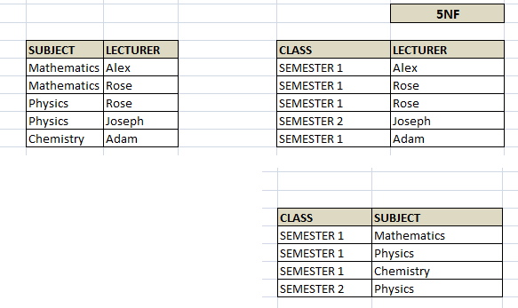
The above relations have join dependency, so they are not in 5NF. That would mean that a join relation of the above three relations is equal to our original relation <Employee>.

FIFTH NORMAL FORM EXAMPLE
Consider an example of different Subjects taught by different lecturers and the lecturers taking classes for different semesters.
Note: Please consider that Semester 1 has Mathematics, Physics and Chemistry and Semester 2 has only Mathematics in its academic year!!

In above table, Rose takes both Mathematics and Physics class for Semester 1, but she does not take Physics class for Semester 2. In this case, combination of all these 3 fields is required to identify a valid data. Imagine we want to add a new class - Semester3 but do not know which Subject and who will be taking that subject. We would be simply inserting a new entry with Class as Semester3 and leaving Lecturer and subject as NULL. As we discussed above, it's not a good to have such entries. Moreover, all the three columns together act as a primary key, we cannot leave other two columns blank!
Hence we have to decompose the table in such a way that it satisfies all the rules till 4NF and when join them by using keys, it should yield correct record. Here, we can represent each lecturer's Subject area and their classes in a better way. We can divide above table into three - (SUBJECT, LECTURER), (LECTURER, CLASS), (SUBJECT, CLASS)

Now, each of combinations is in three different tables. If we need to identify who is teaching which subject to which semester, we need join the keys of each table and get the result.

For example, who teaches Physics to Semester 1, we would be selecting Physics and Semester1 from table 3 above, join with table1 using Subject to filter out the lecturer names. Then join with table2 using Lecturer to get correct lecturer name. That is we joined key columns of each table to get the correct data. Hence there is no lose or new data - satisfying 5NF condition.

